NXT Charting Logger Pass-through Messaging Extensions
Kirk Thompson
5/7/2012

Abstract
This paper will attempt to cover the APIs and user interfaces I have designed and implemented for PID tuning and remote control via a new extensible pass-through messaging architecture for the NXT Charting Logger infrastructure.

PC-side NXT Charting Logger Pass-through Messaging Extensions
The NXT Charting Logger infrastructure consists of Java classes written against the LeJOS platform that run on the PC and provide a Graphical User Interface (GUI) for data logging and dynamic, near real-time charting of incoming data from the NXT sent via a USB or Bluetooth data connection.
The logger protocol is a basic 1-way ATTENTION/COMMAND response state machine. The lejos.util.NXTDataLogger class is responsible for taking data [provided by the programmer via methods that define the data columns and datatypes] on the NXT brick and encoding it in a way that the PC-side NXT Charting Logger client can interpret and thus log to the screen, an optional file, and display the data in a X-Y series plotted with the timestamp of each row of data items plotted against the domain axis while the value is plotted against the Y axis.
The data logging protocol includes a pass-through command that allows an arbitrary stream of byte data to be passed through while the logger is still processing incoming data. The structure of these pass-through messages are defined in NXTDataLogger/NXJChartingLogger Passthrough Protocol Definitions. The Java InputStream and OutputStream classes provide the foundation for this communication and the LoggerProtocolManager class provides the InputStream listener for capturing data sent from the NXT brick.
Utilizing this pass-through message, we have the TunneledMessageManager class which listens to for incoming pass-through (PT) messages parsed by the LoggerProtocolManager class and then passed to registered LoggerListeners. TunneledMessageManager then parses the PT message to extract the PT message command, handler Type ID, and handler ID for further action by the ExtensionGUIManager. The commands:
- CMD_INIT_HANDLER: Initialize a specific handler Type. This will cause loading of an instance of a specific handler type GUI.
- CMD_SET_PLUGIN_NAME: Set the Plug-in Label. A "Plug-in" is the term I have been using for concrete implementations of AbstractTunneledMessagePanel. It can contextually be used interchangeably with Type Handler.
- CMD_DELIVER_PACKET: Lets ExtensionGUIManager forward the message to a specific type handler plug-in.
ExtensionGUIManager then takes the pre-parsed message provided by TunneledMessageManager and routes it to the appropriate type handler as provided by subclasses of AbstractTunneledMessagePanel. It is responsible for instantiating handler type-specific GUI JPanels (subclass of AbstractTunneledMessagePanel) and displaying them in a new tab in the lower Tabbed pane in the NXT Charting Logger client. These tabs provide the GUI and protocol endpoint for pass-through messages.
TunneledMessageManager also provides methods to send data back to the NXT for processing there. This 2-way communication enables command/control scenarios such as the PID Tuning and Robot Driver implementations, possible. All lower level communications processing is sufficiently abstracted away making the development of future extensions relatively easy.
It is fairly straightforward to implement a new handler type by utilizing this messaging architecture:
- A handler type protocol that enumerates all required input/outputs of your implementation must be defined with GETTER and SETTER command IDs.
- A unique Handler Type ID for your protocol must be defined for the new type in PC-side lejos.pc.charting.AbstractTunneledMessagePanel and corresponding NXT-side lejos.util.LogMessageTypeHandler.
- Modify method lejos.pc.charting.ExtensionGUIManager.activateHandler(int, int) to include a case (based on your defined handler type ID) for activation of your plugin, which is simply an instance of your lejos.pc.charting.AbstractTunneledMessagePanel subclass (see (4) below).
- A concrete subclass of lejos.pc.charting.AbstractTunneledMessagePanel must be created. You use the provided utility methods take care of all underlying communication, field datatype validation, etc. so the main effort is to just design the GUI with JFformattedTextFields, JSliders, JButtons, JCheckBoxes, and an optional custom callback method that are "bound" to specific hander type protocol GET and SET command IDs defined by your work done in (1) above.
- Define a lejos.util.LogMessageTypeHandler subclass for your NXT-side implementation and if your plug-in/handler will allow generic implementation, an interface that describes your protocol SET/GET command endpoints (see 1 above) to be implemented.
The PC-side implementation of the plug-in architecture can be further extended using plug-in definitions (your implementation classname, handler type ID, etc) in XML and using dynamic class loading. This would eliminate the modification required in step (3) above. This work has not been done yet.

NXT-side NXTDataLogger extensions (lejos.util)
The NXTDataLogger class is used to send logging command and PT messages to the PC to be processed by the NXT Data Logger client. It provides the InputStream to LogMessageManager via an implementation of the LogMessageListener interface.
LogMessageListener defines the interface that NXTDataLogger uses to pass the InputStream to the LogMessageManager (via a registration process) and provide a callback method for NXTDataLogger to notify LogMessageManager that the stream connection is being closed.
LogMessageManager class provides a singleton instance that takes an NXTDataLogger instance, registers a LogMessageListener with it, and then coordinates message routing with instances of LogMessageTypeHandler. It also provides the InputStream listener endpoint for USB or Bluetooth communication as a threaded process.
LogMessageTypeHandler is the abstract class that all type handlers must subclass. It must have a corresponding AbstractTunneledMessagePanel on the PC-side. It takes care of message decoding for the effecting of protocol commands via an interface that defines the implementation for the handler's protocol commands. It is also responsible for encoding and packaging messages to be sent to the PC via LogMessageManager.

Specific Implementations
SimpleDriveProvider is the interface used for creating a simple robot remote control provider through NXTDataLogger pass-through messaging via a SimpleDrive instance. You must implement and pass an instance to SimpleDrive to remote control your robot from NXT Charting Logger while you [optionally] log and chart data.
SimpleDrive extends LogMessageTypeHandler and allows you to create a class that implements SimpleDriveProvider and register it along with the LogMessageManager singleton to enable NXT Charting Logger to display a driver interface to drive your robot.
PIDTuningProvider is the interface used for creating a PID tuning provider through NXTDataLogger pass-through messaging via a PIDTuner instance. The methods are based on what lejos.util.PIDController implements and what fields the NXT Charting Logger PID tuning lejos.pc.charting.PanelPIDTune displays.
PIDTuner extends LogMessageTypeHandler and is the remote PID tuning extension for NXTDataLogger using the LogMessageManager. It provides an out-of-the-box tuning interface in the NXT Charting Logger for the PIDController class or your own custom PID tuning class. You can create your own PID tuning implementation by implementing PIDTuner in your class and passing an instance of it to the appropriate constructor.

Tuning the PID control
All of the preceding coding effort was used to provide a PID tuning interface that I used to tune the parameters to the PIDController class for a Proof-of-Concept (PoC) ramp balancing robot. This was the test to see if the remote PID tuning was a viable approach. Being able to see the PID controller internals plotted against time with NXT Charting Logger while tweaking the PID parameters, was very useful.

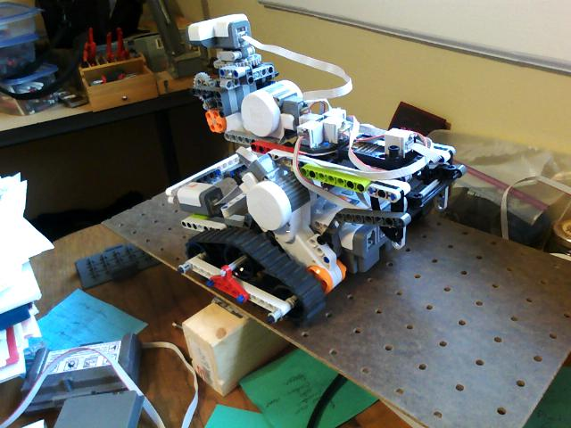
Figure 1: Ramp balancing robot

Using heuristics and continual charting of the incoming data from the NXT, the ramp balancer was tuned to perform well. The Kp term was increased until instability/oscillation occurred and then it was backed off until stable. (TODO provide data) Ki was then introduced in a very small amount so error could be gradually (and slowly) be corrected. Kd was increased from zero until the balance was achieved fairly quickly.
It is interesting to note that the delay (dt) was set pretty long and I was apparently able to take advantage of the dynamics and kinematics of the cyclic ramp pivoting to allow the robot to somewhat match the periodicity and balance with minimal oscillations of the ramp. I believe this will work only if the robot and ramp dynamics do not change much so in effect, this is a very limited test case.

Lejos.util.NXTDataLogger class java source: http://lejos.svn.sourceforge.net/viewvc/lejos/trunk/classes/src/lejos/util/NXTDataLogger.java?revision=6526&view=markup
See NXTDataLogger/NXJChartingLogger Logging Protocol Definitions (NXTDataLogger logging protocol.doc)
NXTDataLogger/NXJChartingLogger Passthrough Protocol Definitions (NXTDataLogger Tunnel protocol.doc)
Lejos.util.PIDController class java source: http://lejos.svn.sourceforge.net/viewvc/lejos/trunk/classes/src/lejos/util/PIDController.java?revision=6526&view=markup

